**Project Design Phase-I**

**Solution Architecture**

|  |  |
| --- | --- |
| Date | 06 May 2023 |
| Team ID | NM2023TMID19401 |
| Project Name | The Meme Museum: A Curated Collection of Hilarity |

**Solution Architecture:**

Solution architecture is a complex process – with many sub-processes – that bridges

the gap between business problems and technology solutions. Its goals are to:

● Find the best tech solution to solve existing business problems.

● Describe the structure, characteristics, behavior, and other aspects of the

software to project stakeholders.

● Define features, development phases, and solution requirements.

● Provide specifications according to which the solution is defined, managed,

and delivered.

**Solution Architecture Diagram:**

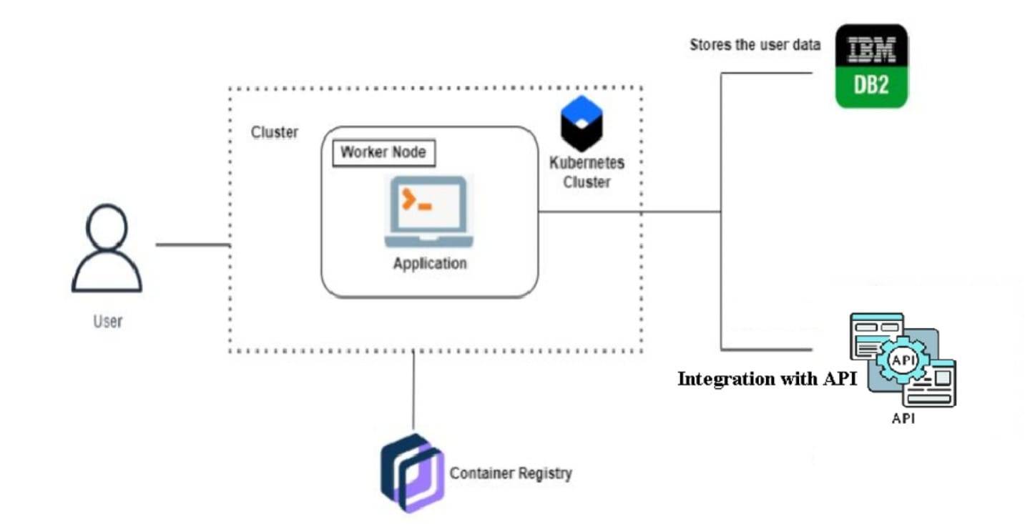

*Architecture and data flow of the voice patient diary sample application*